C. Eradication
1. Goats
Goat extermination has been of an opportunistic nature and was mostly limited to the monthly monitoring visits to Cinq Cases. The ex-warden, Guy Esparon also undertook a few excursions with the sole purpose of hunting goats.
All my spare time at Cinq Cases was awarded to the location and extermination of goats. On occasion, the old Takamaka camp site was used as an overnight ‘fly-camp’ in order to examine the surrounding area for goat activity. In addition, some exploratory ventures were planned into less accessible areas in an attempt to gather evidence of the existence of goats in outlying areas (figure 89).

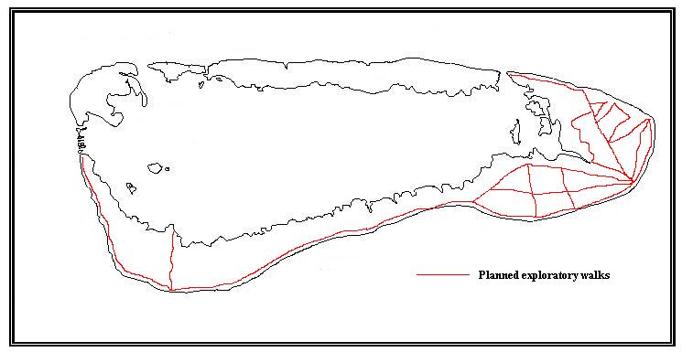
Figure 89: Planned exploratory walks on Grande Terre in 2003

The total number of goats eradicated between February and November this years amounts to 73 of which 41 were males and 32 females. With the addition of the 12 foetuses found in lactating females, the grand total of removed goats totals 85 (see appendix 10 for details).
Goats on Aldabra display a circadian pattern of migration to and from the coast (Gould 1979). This pattern is fairly predictable and a thorough understanding of it is paramount to hunting success. During the heat of the day goats feed within the mixed scrub vegetation concentrating on fresh green growth. Later in the day, depending on the heat, they move back to the coastal champignon to feed on the succulent green growth in crevices of the limestone. In the dry months, the groves area of Cinq Cases becomes prime feeding ground as there is usually much green growth available all year round. For the remainder of the year however, the most productive areas for goat eradication are on the open coastal champignon. Unfortunately, the only functional weapon on Aldabra at present is a pump-action shotgun. Even though this weapon is useful in mixed scrub vegetation where one may get within reasonable proximity of a herd so as to destroy all of them successfully, it does not make for good hunting in areas offering poor cover. A silenced rifle with a telescopic sight would be the most effective weapon in open areas. Often, goats that were not approachable due to a lack of cover were left unharmed as the risk of accustoming the goats “to the evils of man” seemed to outweigh the destruction of only one or two herd members.
Due to a lack of functional GIS software, a description of the location of exterminated goats is not as detailed as may be desired (figure 90). An estimated number of 100 to 200 goats still remain on Aldabra (estimate established by G. Esparon and R. von Brandis, pers obs.). No signs of goats were found west of Takamaka and I am certain that the current goat population is limited to the eastern side of Grande Terre between Anse Cedres and the constriction of the landmass west of Takamaka. The narrow landmass between Dune Jean Louis and Dune d’Messe is characterised by a lack of perennial water and unfavourable habitat for goats and I am under the impression that this section of Grande Terre is acting as a barrier to the more favourable Gros Ilot area. No doubt, if the goat population were left to increase unchecked, goats would most likely establish themselves in these areas again as was the case up until the late middle nineties (Gould 1979)
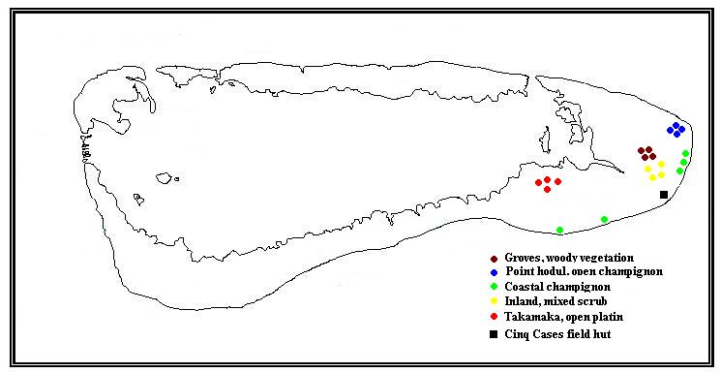
Figure 90: A basic indication of goat extermination sites in 2003

1.1 Recommendations
- At least one rifle should be acquired for Aldabra. The rifle should be of a .243 calibre with a telescopic sight. Bullets should be high speed and expanding (soft nose). These specifications are vital. I am a trained professional hunter and have done much culling work in the past. Goat herds on open champignon could be completely destroyed by a competent marksman. An un-silenced rifle will scare the goats away after the first shot. Solid nose bullets will pierce small holes in the goats resulting in much suffering on the goat’s behalf.
- An aerial census of the Cinq Cases area should be conducted with the use of the FIB. Such an exercise will produce a more reliable estimate of goat numbers and provide more information regarding current distributions of herds.
- Goat numbers are down sufficiently at present and a final assault should be conducted next year. With the help of the FIB and a ground-based hunter, the goat population may be damaged permanently. As I have stated before, I have extensive experience in hunting and in the planning and execution of aerial surveys and I feel that SIF should make use of my skills before the completion of my contract.
2. Cats
A small but sustained population of feral cats has existed on Aldabra since the beginning of the 20th century. Cats are believed to have been introduced to Grande Terre between 1890 and 1900 in order to control rats (Stoddart 1971). Sightings on the other 3 major islands were only reported from the late 1960’s. Cats have been seen swimming in the lagoon (Bourne, data unit) and this fact probably led to the colonization of Malabar and Polymnie with a few cats. The populations on these two islands were never large enough to grow in numbers and therefore became extinct after a few years. The small population on Picard was believed to be completely exterminated in the 1990’s resulting in the subsequent re-introduction of the Aldabra rail.
Except for some opportunistic eradication, the cat population on Grande Terre has been left to its own devices since its introduction in the late 19th century. It is not known how many cats were released but it is safe to assume that there was an increase in numbers over the ensuing years and that at some point the population levelled off. A levelling off had to have occurred as cat numbers have never reached exorbitant numbers on Grande Terre. The most important contributor to this levelling off is the availability of water (Seabrook 1987) and to a lesser degree the availability of food.
Feral cats are shy by nature and irrespective of population numbers, are not often seen. It is therefore difficult to census the population directly. The methods of counting cats from raised platforms and trapping were used in 1986 (Seabrook 1987) and even though some insight regarding distribution of numbers was achieved, these methods are not effective for population monitoring. Indeed, the only method to our disposal is the counting of cat tracks on beaches. Seabrook found that green turtle hatchlings are a major constituent of the cats’ diet and went on to suggest that the number of nesting turtles at Aldabra may be positively correlated to the number of cats. Indeed, an analysis of cat track count data and turtle nests on the West Grande Terre beaches this year, exemplifies a correlation between the number of cats and turtle nests (r²=0.57, p<0.02) (figure 91). In addition, peak cat activity was found to be in conjunction with peak hatchling emergence in September (figure 92).

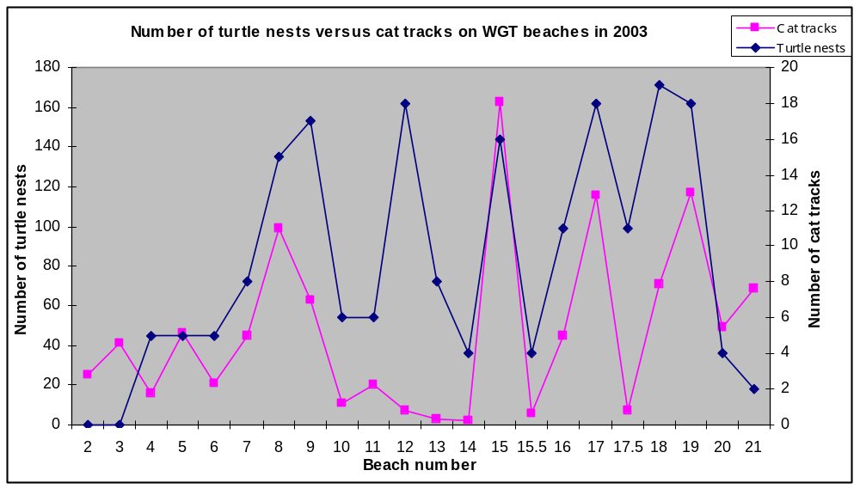
Figure 91: The number of cat tracks against the number of turtle nests along the West Grande Terre beaches in 2003.
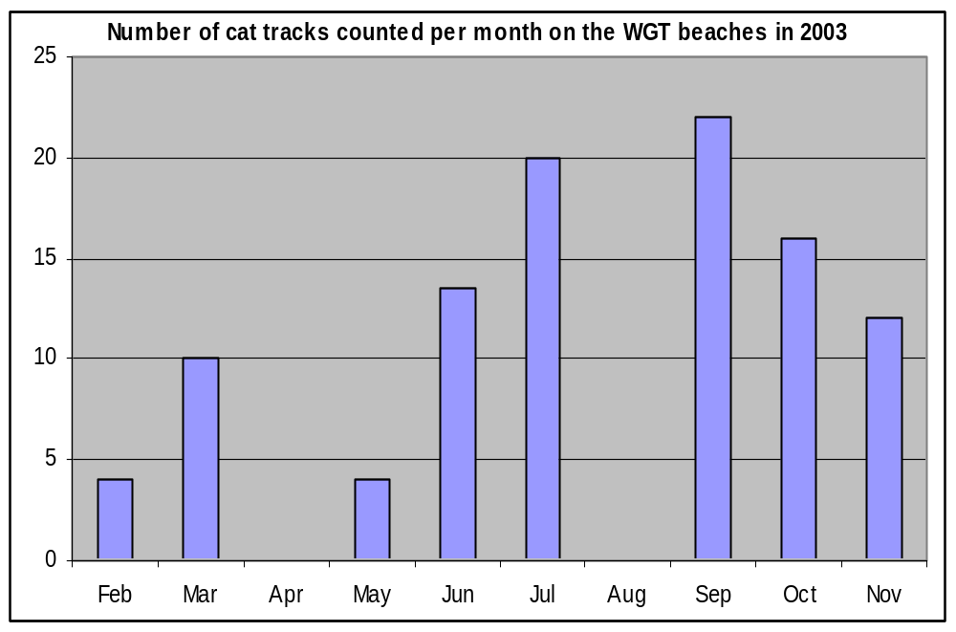
Figure 92: The mean number of cat tracks counted between beach 2 and 21 per month (no counts were conducted in April and August).

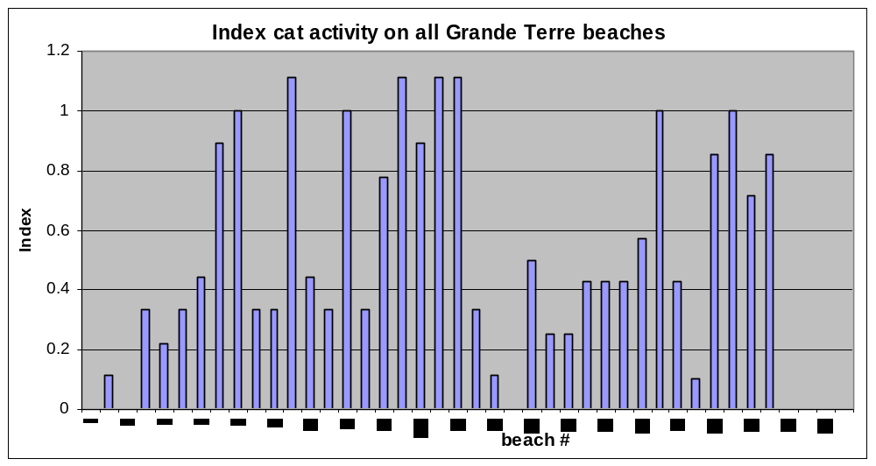
Figure 93: Index of cat activity along all Grande Terre beaches in 2003

As stated before, no exorbitant numbers of cats have ever been recorded during the last century and as a result, it is tempting to argue that we should not expect any population increases in the future. This may or may not be the case but it must be noted that there exists no data to argue either case convincingly. Given the adverse outcomes of a possible population explosion in the future (there are countless accounts of islands having suffered the loss of entire seabird colonies because of cats); it may be wise to address the issue of cats as soon as possible.

To substantiate my request for immediate action, let us consider the known effects that cats are having on various indigenous fauna at present.
- The non-existence of the Aldabra rail on Grande Terre can be chiefly attributed to cats; this fact alone should be enough to substantiate my argument.
- Ground nesting seabirds such as the caspian tern and tropic birds have been noted to have attempted nesting on Grande Terre but failed. It was suggested that the failure was a s a result of the presence of cats (Diamond 1975)
- In the Galapagos Islands cats were noted to feed on tortoises up to two years of age (McFarland et al. 1974). Even though no evidence of this has been found on Aldabra, it is likely to occur.
- Cats consume a large amount of turtle hatchlings and selectively visit beaches exhibiting higher nesting frequencies (Seabrook 1987, Pers. Obs.)
- Cats also consume a large number of rats and even though they may be a strong regulatory factor in controlling rat numbers on Grande Terre, it must be noted that rats have been present on Aldabra prior to the introduction of cats. No significant damage should occur to ecosystems as a result of their increased predatory activities (Seabrook 1987)

In addition the following points should also be noted:
- The larger the cat population on Grande Terre and the longer it is allowed to exist, the better the chance of re-introductions of cats to other islands.
- The larger the cat population, the larger the effort to control them (increased expenses and man-hours).
- No effective method is available to monitor trends in population numbers.

The method of quantifying cat tracks along beaches on Aldabra was introduced to the long term monitoring program this year. Even though some useful data has been derived from this method, the statistical viability of the results is undesirable. The method is limited by the varying abilities of monitoring personnel to identify tracks and to discern between tracks of different individuals. As an experiment, 6 track counts were conducted along the west Grande Terre beaches throughout the month of July. A mean of 20 tracks, ±11 was found. The standard deviation of this dataset is too high to base sound management decisions on the results.

The methods of cat extermination were discussed in past monthly reports. Mr. Richard White, who has some experience in this regard, was consulted for advice. The use of baited ‘cage traps’ is not viable for extermination purposes as unsatisfactory catches of 129 trap-nights per cat were found in the past (Seabrook 1987). The use of ‘leg-catch’ traps and poisons should be strictly prohibited in view of non-target species. Opportunistic extermination via shotgun does not yield the desired results and requires a high degree of effort and man-hours. It is my impression that we are left with only two options, both of which should be employed as soon as possible.

2.1 Eradication option 1: The design of a baited live-catch trap with a ‘surprise opening’ mechanism.
The traps used by Seabrook required the cat to crawl through an opening and pull at the bait before it was effectively trapped. The fact that the cat had to willingly crawl through a confined space into a foreign object was most likely the chief contributing factor to the poor success rates. An idea suggested by Mr. Chong Seng and adapted by myself may remove this factor from the equation. A mechanism whereby the weight of the cat causes it to fall through an opening is suggested in figure 94.

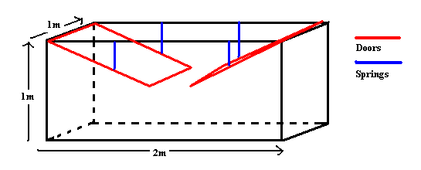
Figure 94: Proposed design of ‘surprise door’ cat trap

It is proposed that this trap be built from available materials at the station and used in a feasibility survey. The trap should be buried halfway in the sand at the top of a suitable beach. Fresh fish and other olfactory attractants should then be put inside the trap and the springs set to only hold the lightweight doors up. The trap should be camouflaged with rocks and beach debris. A cat may then be tempted to jump onto the smoothed doors and fall into the trap with the doors closing neatly over its head.

2.2 Eradication option 2: The use of one trained dog to follow cat spoor.
The use of dogs in following and treeing cats is well documented. I have personally partaken in such hunts in the past and can vouch for the effectiveness of this method. One trained dog could be used during organised hunting trips where tracks are followed from beaches in the morning or during opportunistic hunts. The dog is trained to follow the tracks and chase the cat until it seeks refuge in a tree or in its lair. The hunter follows and disposes of the cat on site. One trained dog that is to stay under the watchful eye of the owner at all times can have no adverse effects on the environment. If the dog were to become adverse to hunting birds or other indigenous fauna, it is to be removed from the island with the next transport at the demise of the owner.

2.3 Recommendations
- The use of one dog should be permitted on Aldabra. I have had dogs all my life and will take full responsibility for the actions of my dog. SIF will reserve the right to request the removal of the dog from the island at any given time.
- Some additional materials may be needed to build the trap and should be sent over to the island on my return to the island in 2004.
- Additional advice regarding methods of extermination should be sought from outside sources.

3. Rats
Aldabra supports a well-established population of black rats (Rattus rattus). Very little research has been awarded to the subject of rats on Aldabra. Quantitative data and regional impact assessments of rats on various ecosystems is sorely needed.

3.1 Rat trap transects
Limited surveys were conducted this year with the intention of establishing major differences is population sizes. Trap transects were set out at various locations around the atoll. Traps were inspected the following day and, depending on the state of the trap, were classified into four categories:
- Trap closed with no catch
- Trap open with gnaw marks on the bait
- Trap closed and containing a rat
- Trap closed and containing a robber crab.

In table 42; the number of effective traps was calculated by subtracting traps in categories 1 and 4 form the total number of traps set. The number of evident rats was calculated by summing traps in categories 2 and 3. Success percentage was calculated by the division of the number of evident rats by the number of effective traps. For transects that were conducted more than once, means were calculated for each category.
At Middle camp, traps were set out on two consecutive nights in the same area. Success percentage was calculated at 70% for the first night and at 40% for the second. Three months later (May) the transect was conducted again with a success percentage of 40%.

Table 42: Results of rat trap transects conducted around the atoll in 2003.
Transect | # of effective traps | # evident rats | success percentage
Ile Esprit | 16 | 16 | 100%
Ile Emile (west channels) | 11 | 10 | 91%
Ile Yangue (west channels) | 12 | 10 | 83%
Anse Malabar | 10 | 8 | 83%
Ile Lanier (west channels) | 11 | 9 | 82%
Unnamed island (west channels) | 15 | 12 | 80%
Polymnie rail transect | 12 | 7 | 58%
MC Casuarina | 14 | 6 | 43%
Gionnet rail transect | 12 | 5 | 42%
Middle camp | 16 | 6 | 37%
Ile Moustique beach 50d | 23 | 7 | 30%
Ile Moustique beach 50e | 5 | 0 | 0%

In May this year, a large scale trapping program was informally proposed to the scientific committee. As result of subsequent discussion, it was decided not to conduct large scale trapping excursions for the following well-founded reasons:
- As yet, there is no data indicating that rats do indeed damage or threaten the natural ecosystems of Aldabra.
- The time and financial constraints in conducting a large scale trapping program are not feasible.
- Large scale trapping may promote the survival of genetically superior rats that display caution around traps.
- A reduced rat population will grow back to a saturated state in a relatively short span of time resulting in a continuous and intensive ‘follow-up’ trapping effort.
3.2 Rat impact project
The scientific committee, in conjunction with the R/O then commenced designing a project proposal aimed at determining the impact that rats have on certain ecosystems on Aldabra. Unfortunately, the project was abandoned a month later. Below are the basic objectives and methodology that were proposed in June.

3.2.1 Objectives:
- To determine to which degree rats affect the fauna and flora of Aldabra by using a smaller island as an empirical sample.
- To use the results of the survey to re-define the management of rat populations on Aldabra.
3.2.2 Method:
Phase 1:
- To select an island with a relatively high estimated species diversity (fauna and flora), with a saturated rat population and of a correct size (the correct size will be a trade-off between logistical limitations and effective sample size)
- To determine the species composition and abundance of the herbaceous and woody plant component of the island
- To do a species inventory of vertebrates (especially birds)
- To determine the relative abundance and diversity of the invertebrate component as instructed by Justin.
- To count rat nests and to identify the plant species used for making nests.
- To identify any visual damage to vegetation (e.g. ‘chewed up’ buds or seeds)
Phase 2:
- Kill all the rats! This will be done by repetitively setting out traps in grid patterns using a variety of baits until no rats are caught 2 or 3 times in a row.
- To dissect each rat in an attempt to identify stomach contents. (All health care safety measures will be taken)
Phase 3:
- Allow species abundances and diversity to adapt to the removal of the rats.
- Re-survey the island using the same methods.

Before the project was abandoned, an investigation of all the islands in the west channels was conducted with the purpose of finding a suitable site for the project. Four suitable islands were identified and described as follows:

“All four islands are composed of serrated and pitted limestone. There is sufficient leaf litter on each island for the invertebrate study. No brown noddies were sighted on any of the islands; however, the breading season only begins in September. (Brown noddies are still being sighted on other smaller islands in the west channels). Accessibility is limited on all four islands as the vegetation is very thick. Limited clearing will be necessary to traverse islands. Skinks were sighted on all the islands whereas crab diversity is undetermined. There are strong currents between successive islands limiting immigration of rats from other areas. Rats were found on all four islands with similar population densities (densities are not based on statistically reliable data as only one ‘12 trap’ transect has been conducted on each island so far. Transects were placed with the intension of confirming the existence of rats)” (June 2003 R/O report)

Island 1: Ilot Emile (see figure 95)
Area: 1.7 hectares
Rat trapping success =91%
Habitat description: Island is dominated by mixed scrub with small localized patches of Pemphis acidula and a narrow mangrove fringe. Notable plant species of the mixed scrub constituent included :( not in order of dominance)
Azima tetracantha, Allophylus aldabricus, Sideroxylon inerme, Plumbago aphylla, Lomatophyllum aldabrense. A few orchids (Angraecum) were also seen.

Island 2: Ilot Yangue
Area: 2.7 hectares
Rat trapping success =83%
Habitat description: Island is dominated by mixed scrub with a small mangrove stand on the east end. Localized patches of Pemphis acidula are also common. A ‘mini lagoon’ exists in the mangrove stand. The island is also fringed by mangroves in some places. Notable plant species of the mixed scrub constituent included :( not in order of dominance)
Achyranthes aspera, Sideroxylon inerme, Allophylus aldabricus, Lomatophyllum aldabrense, Dichrostachys microcephala, Cordia subcordata.

A significantly larger spider population was observed (some species that I hadn’t seen before). A dense spider population is indicative of dense insect populations.

Island 3: Ilot Orchidee
Area: 3 hectares
Rat trapping success =106%
Habitat description: Island is almost completely dominated by mixed scrub. Limited small localized stands of Pemphis acidula are present. A few mangrove trees are found on the island fringes. Notable plant species of the mixed scrub constituent included :( not in order of dominance)
Sideroxylon inerme, Lomatophyllum aldabrense, Angraecum eburneum, Azima tetracantha, Allophylus aldabricus, Plumbago aphylla. The Aldabra Lilly (Lomatophyllum aldabrense) and the orchids (Angraecum eburneum) are found in high densities. This island was investigated last year due to reports of evidence that rats had been eating the bases of the Lillie’s inflorescences. This evidence was confirmed. The initial rat transect produced a 106% trapping success (all the traps effective with 2 rats in one trap).

Island 4: Ilot Lanier
Area: 3 hectares
Rat trapping success =82%
Habitat description: This Island consists of three vegetation types. The largest component (approx. 50%) includes mixed scrub. The remaining area is composed of an extensive mangrove stand (approx. 30%) and a Casuarina equisetifolia stand (approx. 20%). The mixed scrub community seems to share its species composition with that of island 3 (however, the vegetation was too thick to move through).
Five tortoises were also found under the Casuarina stand
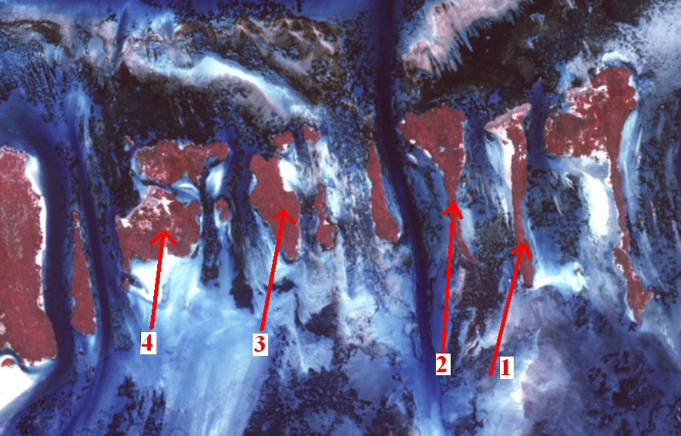
Figure 95: Suitable islands in the west channels for the rat project

3.3 Recommendations:
- The rat project should be re-initiated under the auspices of a willing graduate student. The student/s should originate from a university that has the facilities to analyse the contents of large numbers of rat stomachs.
- Total eradication of rats on smaller ilots in the lagoon should be approved. The uses of the new ‘continuous action’ traps sent out with the October supply boat are suited for this. Certain seabirds such as red-tailed tropic birds and brown noddies are restricted to nesting on small ilots as they are not known to coexist with rats (Diamond 1975). It should be a fairly simple task to clear small ilots (no larger than 100m²) of rats. For example, when travelling to Cinq Cases for the usual 3-4 day monitoring trip, continuous action traps could be placed on ilots along the way and collected on the way back.

